Chapter 19, Solution 64.

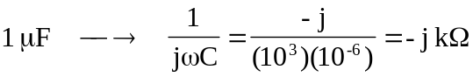

Consider the op amp circuit below.
−
+
-j k
10 k
20 k
V_{x}
2
I₁
I₂
+
V₂
−
40 k
1
+
V₁
−

At node 1,
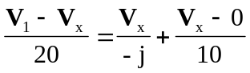
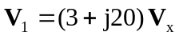 (1)

At node 2,
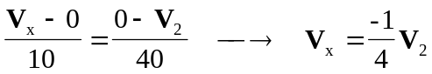 (2)

But 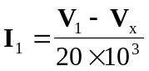 (3)

Substituting (2) into (3) gives
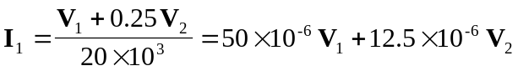 (4)

Substituting (2) into (1) yields
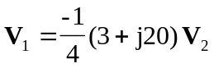
or 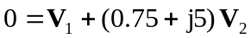 (5)

Comparing (4) and (5) with the following equations
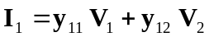
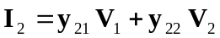

indicates that 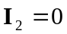 and that
